**SPRINT 3**

|  |  |
| --- | --- |
| **Date** | **10 November 2022** |
| **TEAM ID** | **PNT2022TMID43101** |
| **Project name** | **IOT Based Smart Crop protection System for Agriculture** |
| **Mark** | **20 marks** |

1. MIT App inventor to design App

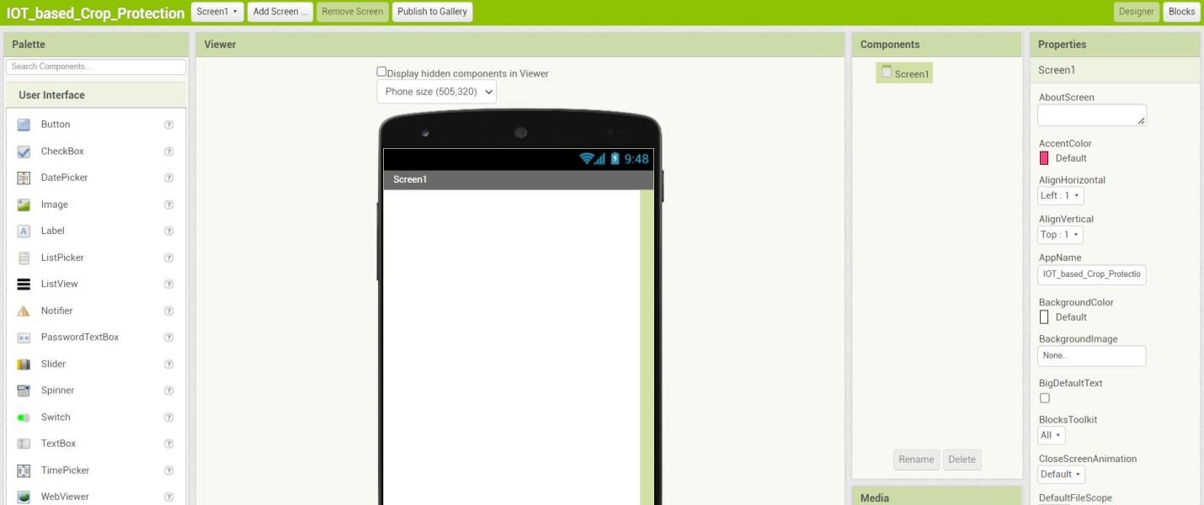

1. Design and testing the app to get values

